**NLP INFERENCES**

Snapdeal reviews: LG TV

* Most reviews are positive about the Picture quality and happy about sound and recommendation about the product itself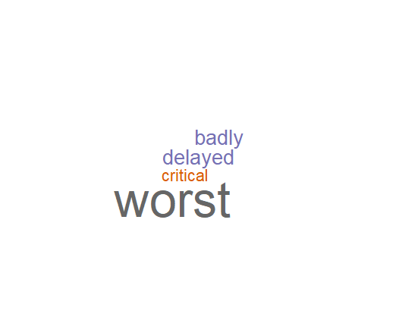.
* Most frequently positive words occurred are:
* # good Snapdeal delivery service worst quality
* # 40 15 16 12 12 14
* Negative comments are about: delayed, delivery, critical condition, received

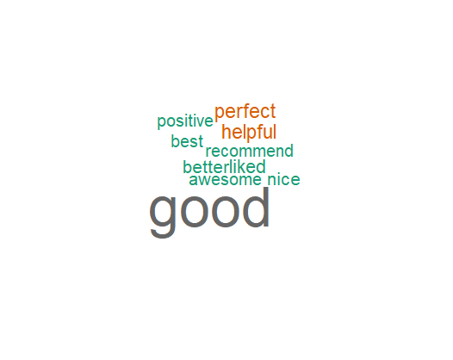

* Overall reviews are Average regarding the Snapdeal service : it has received negative comments about the service after delivery .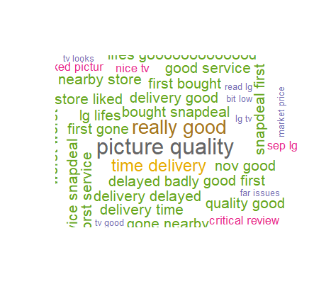
* IMDB reviews: Joker (2019)
* Reviews are majority of them are positive as the movie was given positive response mostly.
* Mostly words occurred in reviews:
* #acting best character good Joaquin October phoenix plot society
* #12 16 10 15 17 18 16 12 12
* Word Cloud of positive:

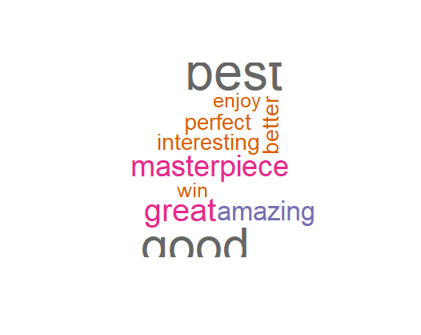

* Most Negative reviews are about “Overrated”, “Hype” , “boring” “murderer” .Which is related to plot of the movie .

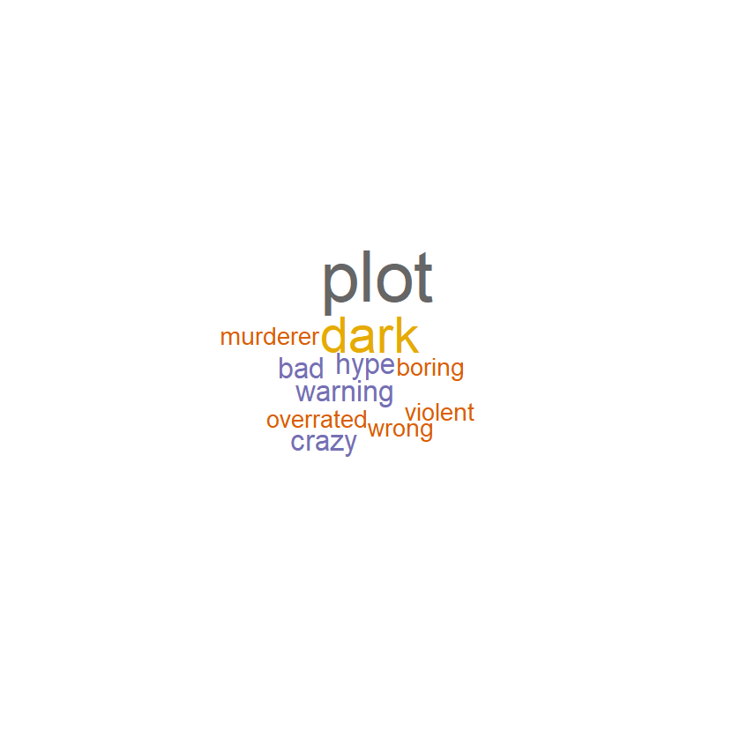

* Overall Rating of the movie is it is Masterpiece.
* “October “ frequency is quite high as many people watched the movie as soon as it was released.(October) due to Hype.
* People mentioned the main actor Joaquin as nominated as Oscar worthy performance and also Todd Philips.

